P1201242 – shipping / deleting problems

From: Shipping Dept <shipping@norstarwindows.com>
Sent: Tuesday, March 14, 2023 8:06 AM
To: Greg Ford <gford@norstarwindows.com>; Christine Cameron <christine@norstarwindows.com>; Greg Coulter <gregc@norstarwindows.com>
Cc: Janet Norman <janet@norstarwindows.com>
Subject: RE: PO2301542

I had open packing slip that I couldn’t delete and I approved it but couldn’t create invoice
Christine, could you or Greg please look into this

Thanks

From: Greg Ford <gford@norstarwindows.com>
Sent: Tuesday, March 14, 2023 7:56 AM
To: Shipping Dept <shipping@norstarwindows.com>
Cc: Janet Norman <janet@norstarwindows.com>
Subject: RE: PO2301542

Hi Svjetlana,

Line 29 - needs to be deleted from sales order. However I cannot delete.
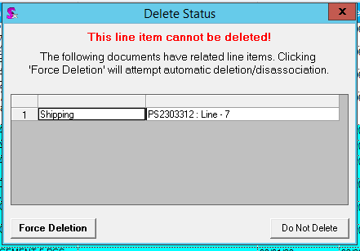

Line 42 – need to change quantity to 1. But I am getting this error.

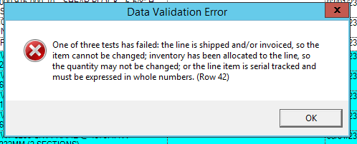

From: Shipping Dept <shipping@norstarwindows.com>
Sent: March 14, 2023 7:44 AM
To: Greg Ford <gford@norstarwindows.com>
Cc: Janet Norman <janet@norstarwindows.com>
Subject: PO2301242

Good morning Greg,

Please see below sales order and receiving doesn’t match, LN 29 received 4 pcs on the PO there is no LN29
and LN 42 PO has 1 pc, sales order 2 pcs

